Exercise: Continuous Integration
Exercises for the "Back-End Test Automation" course @ SoftUni

In this exercise you will set up CI in two ways:
Primary (recommended): GitHub Actions (runs on every push / pull request).
Optional extension: Jenkins Pipeline (useful when an organization is locked into Jenkins or needs on-prem control).

Prerequisites
- A GitHub account and a repository for each app.
- Git installed locally (or GitHub Desktop if you must).
- Node.js project: npm available locally for the "run locally" part.
- .NET project: .NET SDK available locally for the "run locally" part.
Note on ports: Jenkins often uses 8080 by default. The Student Registry app also uses 8080 in the resources. If you do the optional Jenkins part, configure Jenkins on a different port (for example 8081) to avoid a port conflict.

GitHub Actions (recommended)
GitHub Actions lives next to your code. No extra servers, no tunnels, no ritual sacrifices. It is the default CI choice when your code is already on GitHub.

"Student Registry" (Node.js)

Step 1: Run locally
Open the project and run:
npm install
npm start

In a second terminal:
npm test
Expected result: tests pass locally.
If tests fail here, GitHub Actions will also fail later.

Step 2: Create a GitHub repository
- Go to GitHub → New repository.
- Name it something like: student-registry or student-registry-ci
- Create the repo without a README (optional, but easier for this exercise).
- Copy the repo URL (it looks like https://github.com/<username>/<repo>.git).

Step 3: Create .gitignore in the project root
In your project root (project root = the folder where your package.json is), create a new file named exactly:
.gitignore (yes, it starts with a dot)

Put this inside:
# Node dependencies
node_modules/

# Logs
npm-debug.log*
yarn-debug.log*
yarn-error.log*

# Environment files (often contain secrets)
.env
.env.*
Save the file.

Step 4: Push the project to GitHub (first time)
git init
git add .
//optional check if .gitignore works as intended
git status
//Look for these:
// Good: you do not see node_modules/ anywhere.
// Bad: node_modules/ appears under "Changes to be committed".
git commit -m "Initial commit"
git branch -M main
git remote add origin <URL>
git push -u origin main
* You might experience the following warnings after git add.:
- warning: in the working copy of 'package-lock.json', LF will be replaced by CRLF the next time Git touches it
- warning: in the working copy of 'package.json', LF will be replaced by CRLF the next time Git touches it
Those warnings are Git being dramatic about line endings. Don't worry!

Step 5: Add the GitHub Actions workflow file (do this in VS Code locally)
In the project root → New Folder
Name it: .github
In the .github folder → New Folder
Name it: workflows
In the workflows folder → New File
Name it: ci-student-registry.yml
So, the final path is exactly: .github/workflows/ci-student-registry.yml
In this workflow file add:
name: CI - Student Registry (Node.js)

on:
push:
pull_request:

jobs:
test:
runs-on: ubuntu-latest

steps:
- name: Checkout
uses: actions/checkout@v4

- name: Set up Node.js
uses: actions/setup-node@v4
with:
node-version: 24.x
cache: npm

- name: Install dependencies
run: npm ci

- name: Start app (background)
run: npm start &

- name: Wait for app to be ready
run: npx --yes wait-on http://localhost:8080

- name: Run tests
run: npm test
What this workflow does (simple explanation):
- Installs Node.js
- Installs dependencies (npm ci for consistent installs)
- Starts the app in the background
- Waits until the app responds on http://localhost:8080
- Runs tests

Step 6: Commit and push the workflow
Run:
git add .github/workflows/ci-student-registry.yml
git commit -m "Add CI workflow for Student Registry"
git push

Step 7: Check it in GitHub
- Open your GitHub repo.
- Click Actions tab.
- You should see a run called: CI - Student Registry (Node.js)
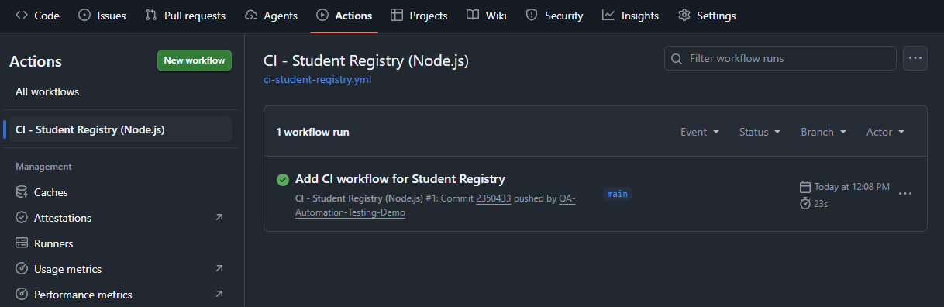
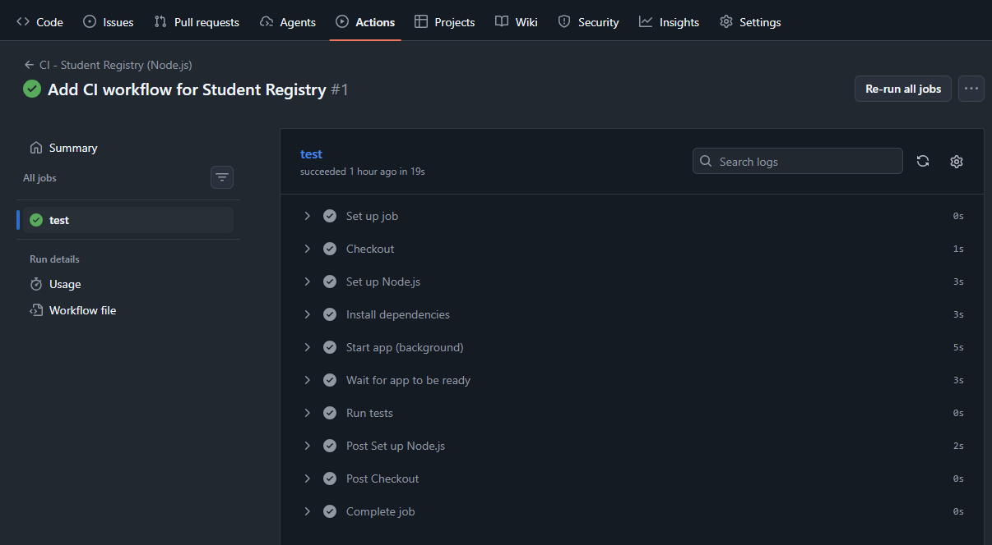

"House Renting System" (ASP.NET Core)

Step 1: Run locally (verify the project builds and tests run)
Open a terminal in the solution folder (the one with the .sln) and run:
dotnet restore
dotnet build
dotnet test

Expected result: build succeeds and tests run.

Step 2: Create a GitHub repository, add .gitignore and push project to GitHub
(Easiest way in Visual Studio)

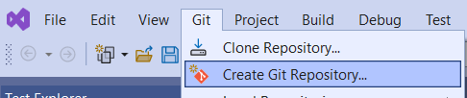

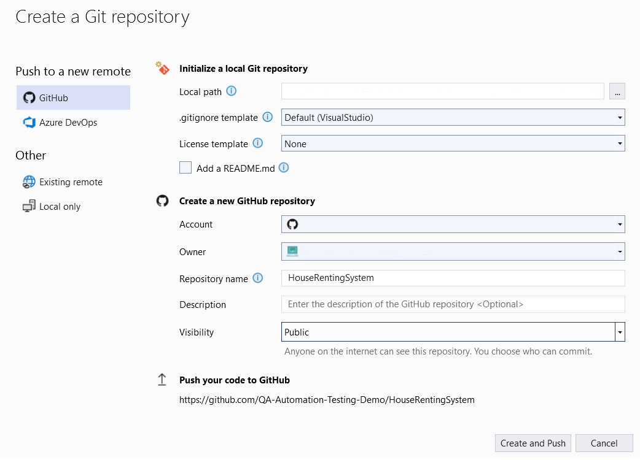
Local path: It should point to the project folder on your PC (the folder with the .sln for HouseRentingSystem).
.gitignore template: choose Default (VisualStudio) This is important. It prevents committing bin/, obj/, .vs/, etc.
License template: choose None
Add a README.md: leave unchecked (optional) Keep it unchecked to avoid extra noise in the first commit.
Account: select your GitHub account (the one you’re logged into in Visual Studio)
Owner: select your GitHub username
Repository name: set to House-Renting-System-CI
Description: leave empty (optional)
Visibility: Choose Public
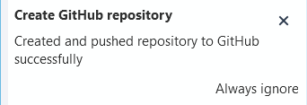

Step 3: Add GitHub Actions workflow for .NET (Windows + Visual Studio), Commit and Push
- Visual Studio: Git → Open in File Explorer
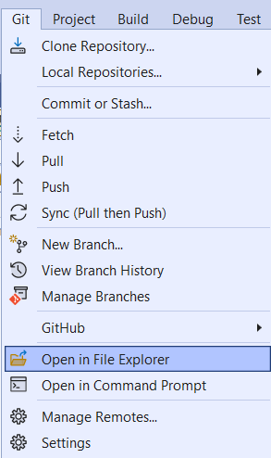
- In the repo root (same folder as .sln), create:
  - .github
  - .github/workflows
- Create the file:
  - .github/workflows/ci-house-renting.yml
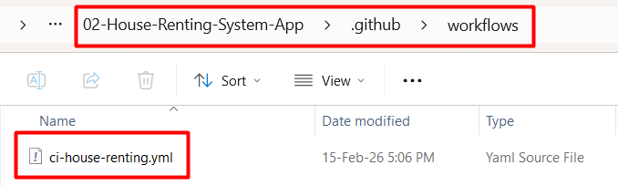
- Paste YAML:
name: CI - HouseRentingSystem (.NET)

on:
push:
pull_request:

jobs:
build-test:
runs-on: ubuntu-latest

steps:
- name: Checkout
uses: actions/checkout@v4

- name: Set up .NET SDK
uses: actions/setup-dotnet@v4
with:
dotnet-version: 8.0.x

- name: Restore
run: dotnet restore

- name: Build
run: dotnet build --no-restore

- name: Test
run: dotnet test --no-build
- Save

- Visual Studio: Git → Commit or Stash…
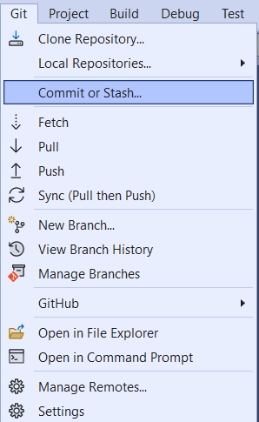
- Commit All → Push
- GitHub → Actions tab → confirm workflow run.
Note: Solution Explorer in Visual Studio may not display .github/workflows. That is normal.
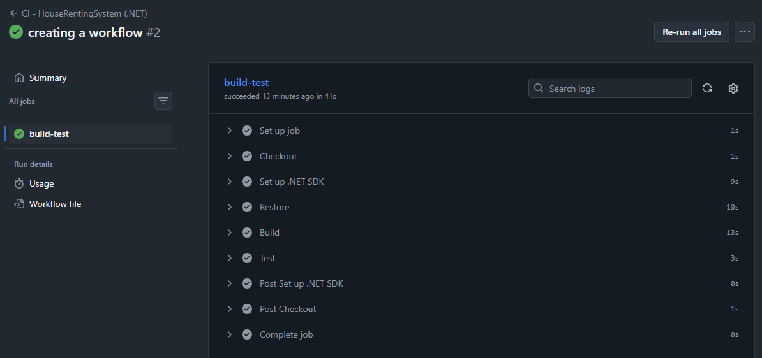

Quick self-check (do this yourself)
Your GitHub Actions workflow runs every time you push a commit. Prove it:
- Make a tiny change in your repo (pick one):
  - Edit README.md and add a single line like: CI trigger test
  - Or add a comment in any code file (no functional change)
- Save the file.
- Commit and push:
  - In Visual Studio: Git → Commit or Stash… → Commit All → Push
  - Or in terminal:
  - git add .
  - git commit -m "CI trigger test"
  - git push
- Open your GitHub repo → Actions tab.
- You should see a new workflow run started by your latest commit.
If you don’t see a new run, you either didn’t push (common) or you’re looking at the wrong branch.

* Jenkins Pipeline (Optional)
Jenkins is still common in enterprises. The goal here is not to worship it. It is to recognize it, then move on.

Install Jenkins
You already have a separate document called "Jenkins Installation Guide" that walks you through the installation step by step (including Java setup, port selection, and the initial unlock). Follow that guide before continuing with the exercise.

"Student Registry" (Node.js)

Step 1: Create the Jenkins job (Pipeline)
- In Jenkins dashboard, click New Item
- Name: student-registry-pipeline
- Select Pipeline
- Click OK

Step 2: Create the Jenkinsfile
Best practice: Jenkinsfile lives in the GitHub repo.
In the root of your Student Registry (same folder as package.json), create a file named exactly:
- Jenkinsfile (no extension)

Step 3: Paste this Jenkinsfile (Windows)

pipeline {
agent any

stages {
stage('Checkout') {
steps { checkout scm }
}

stage('Install dependencies') {
steps { bat 'npm ci' }
}

stage('Start app (background)') {
steps {
bat 'start /B cmd /c npm start'
}
}

stage('Wait for app') {
steps {
bat 'npx --yes wait-on http://localhost:8080'
}
}

stage('Run tests') {
steps { bat 'npm test' }
}
}

post {
always {
// Cleanup so the port isn't left occupied after the build
bat 'npx --yes kill-port 8080'
}
}
}

Step 4: Commit and push it
git add Jenkinsfile
git commit -m "Add Jenkins pipeline"
git push

Step 5: Configure the job to use the Jenkinsfile from GitHub
Open your Jenkins job → click Configure
Scroll to Pipeline. Set:
- Definition: Pipeline script from SCM
- SCM: Git
- Repository URL: your GitHub repo URL
(example: https://github.com/<username>/<repo>.git)
- Branches to build:
  - */master if your repo uses master
  - */main if your repo uses main
- Script Path: Jenkinsfile
- Click Save

Step 6: Run the CI pipeline
- Click Build Now
- Click the build number (left side)
- Open Console Output
Expected stages:
- Checkout
- Install dependencies
- Start app
- Wait for app
- Run tests
In this exercise, Jenkins builds are started manually with Build Now. To run Jenkins automatically on each commit (like GitHub Actions), Jenkins needs a trigger (webhook or polling). Webhooks require Jenkins to be reachable from the internet, which is why this is optional/advanced for local installations.

